Business Process: Commercial Economic Development Rate

Contact
Business Process Owner | Commercial Development and Business Attraction
Subject Matter Expert(s) | Billing Solutions CSR II and Sr. CSR, Strategic Advisor, Economic Development and Business Growth Specialist
Key Contact | Supervisor, Billing Solutions; Manager, Account Management & Sales; Supervisor, Strategic Account Management; Strategic Advisor; Manager, Economic Development and Business Growth; Economic Development & Growth Specialist
Key Role | Billing CSR II and Sr. CSR, 3rd Party Vendor, Strategic Advisor, Economic Development & Growth Specialist, COS BTA, SAPCCA ETA
Date Created | March 3, 2026

Business Process Overview
SMUD offers an Economic Development Rate Option (EDR Option) which provides multi-year discounts on selective billing components for qualifying General Service customers. Customers can seek this option for attraction (new to SMUD territory, retention (keep a customer, and expansion (to support an expansion at an existing site).

Eligible customers have two options to receive a reduction of the System Infrastructure Fixed Charge, Site Infrastructure charge, Summer Super Peak Demand Charge (or Summer Peak Demand Charge), and electricity usage charges on their bill.

Both discount options are for 10 years. One option provides a graduated discount over the 10 years, and the other option provides a static discount over the 10 years

Business Process Assumptions, Prerequisites, Dependencies
(Assumptions pertaining to the business process)
People | - Billing Solutions: CSR II and Sr. CSR  - COS Business Technology Analyst  - SAPCCS Enterprise Technology Analyst  - Commercial Development & Growth Specialist  - Strategic Account Advisor  - 3rd Party Vendor
Process | - Prerequisite: Baseline usage will be determined for expansion EDR customers only  - If baseline usage has been established, IT creates the baseline in SAP with a Service Now ticket; otherwise, the customer will receive a discount on the entire bill components eligible for the discount
Technology | - SAP, EDM, SharePoint, MS Excel

Process Flowchart
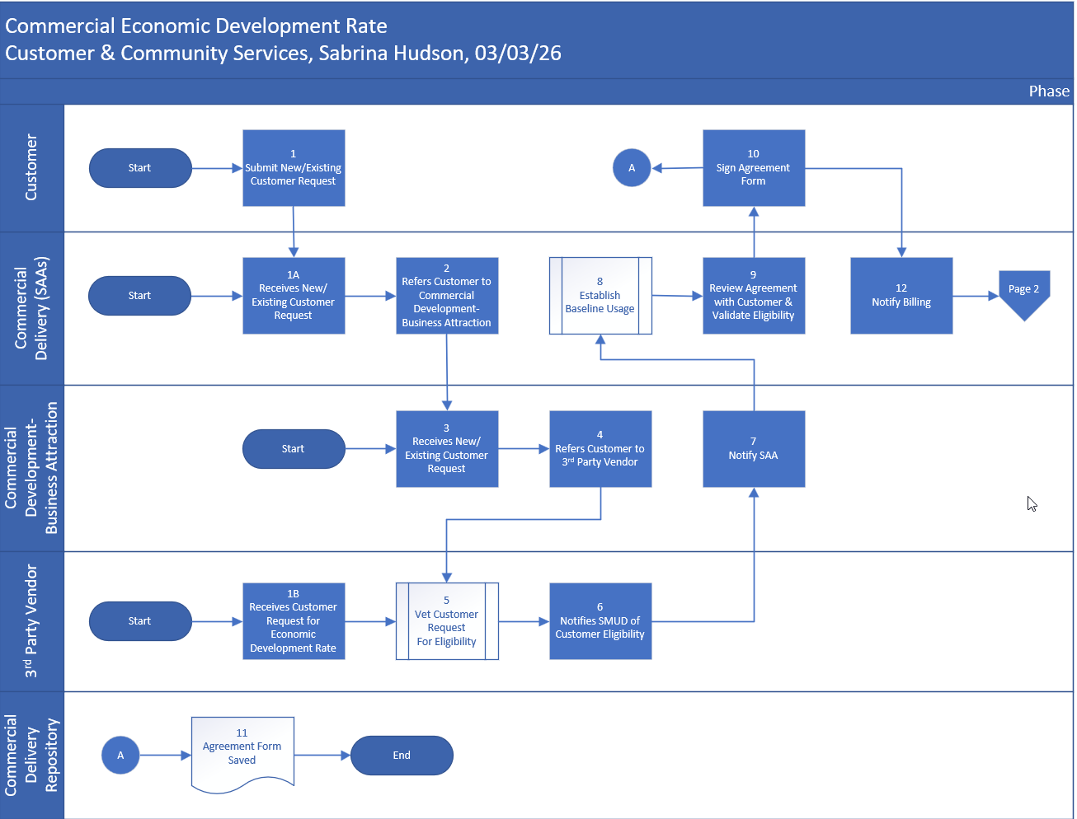

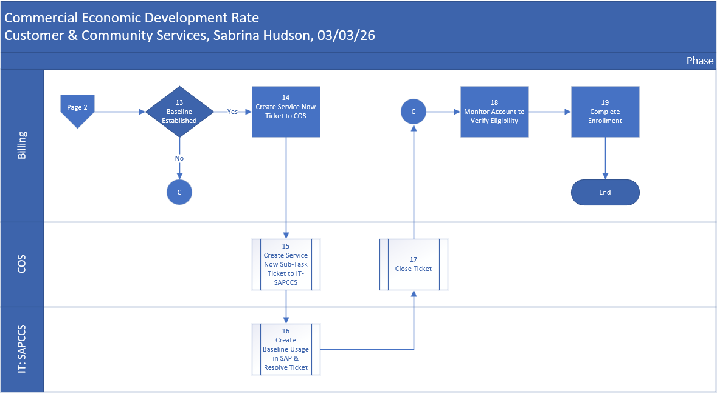

Task Description
Id | Task Description | Procedure
1 | Submit New/Existing Customer | This can be a phone call, letter, email, or face to face conversation initiated by the customer
1A | Receives New/Existing Customer Request | This can be a phone call, letter, email, or face to face conversation with the assigned SAA
1B | Receives New/Existing Customer Request | This can be a phone call, letter, email, or face to face conversation with the 3rd Party Vendor
2 | Refers Commercial Development – Business Attraction | SAA Referral to Commercial Development – Business Attraction
3 | Receives New/Existing Customer Request | Receives request directly from customer or as a referral from SAA
4 | Refers Customer to 3rd Party Vendor | All requests must be referred to the 3rd Party Vendor for vetting of eligibility
5 | Vet Customer Request for Eligibility | This task is performed by the 3rd Party Vendor
6 | Notifies SMUD of Customer Eligibility | 3rd Party Vendor notifies SMUD in writing of customer eligibility – Commercial Growth Specialist or SAA can receive this correspondence
7 | Notify SAA | SAA is notified when eligibility is confirmed with Commercial Growth Specialist
8 | Establish Baseline Usage | SAA establishes baseline usage using previous 12 months of usage. SAAs will complete this task for all Expansion customers to include ones that originated/flowed through the Commercial Development – Business Attraction
9 | Review Agreement with Customer & Validate Eligibility | SAA meets with the customer to review agreement and validate eligibility. SAA will obtain customers’ signature on the agreement form.
10 | Sign Agreement Form | Customer signs agreement form
11 | Agreement Form Saved | SAA will save the signed form to the Commercial Delivery Repository
12 | Notify Billing | SAA will notify Billing of the new customer to be set up on the rate
14 | Create Service Now Ticket to COS | Billing creates a ticket for Baseline Usage to be added to SAP (if baseline usage has been established by the SAA)
15 | Create Service Now Sub-Task Ticket to IT-SAPCCS | COS assigns ticket and then creates a sub-task ticket to IT – Customer (aka SAPCCS)
16 | Create Baseline Usage in SAP & Resolve Ticket | SAPCCS creates the baseline usage in SAP then resolves the sub-task
17 | Close Ticket | COS resolves/closes Service Now ticket
18 | Monitor Account to Verify Eligibility | Billing monitors accounts to verify eligibility - Customer peak demand must reach at least 300kW within 12 months of signing the agreement.
19 | Complete Enrollment | - Access account via ZCSBH  - Click on Utility Installation and click the pencil  - Click Facts button  - Click Operand  - Enter M_DISCOUNT and click green checkmark  - Enter Discount for each time slice (10 years) based on Options table  - Click Transfer  - Click Operand  - Enter M_ECON_DH and click green checkmark  - Enter Valid to date (10 years out), then click checkmark, then click transfer  - Click double green back arrow, then click the save icon  - Add a Device Location note  - Add to Manual Billing spreadsheet for follow-up at on-cycle to verify discount is applied accurately  - Add to the Change Request Log for the Manual Billing spreadsheet

Business Rules
Id | Event Name | Business Rules
8 | Establish Usage Baseline | - Accounts with baseline will be required to bill to monthly on cycle for the credit to be applied accurately. The Customer will need to be aware.
19 | Complete Enrollment | Solar Billing & ED Option  - ED Option discount  - Calculated and applied to the calculated energy charge (pre-generation credits) for energy above the unnetted baseline kWh  - Not included in any carryover calculation to subsequent bills  - Solar & Storage Rate / Net Energy Metering  - SSR and NEM work as designed independent of the ED option  - Current SSR/NEM generation credits continue to offset current month gross energy charges independent of the ED option discount  - Prior SSR/NEM generation credits continue to carryover to current month and apply to current month energy charges independent of ED option discount  - User Utility Tax is applied post ED option discount

Event | Legal Requirements, Rules, and Regulations  Legal documents/ procedures/ requirements to be fulfilled before/at the specified event.
Id | Event | Legal Requirements, Rules and/or Regulations
9 | Review Agreement with Customer & Validate Eligibility | SB535 provides customers with two options to receive a higher discount. One option is graduated and the other is static

Pain Points and Improvement Opportunities
- Opportunity: Can Billing add the baseline usage operand for the full year? Currently it is month by month.

Departments impacted by process change (Required)

Department | Type of Change(s) | Action Required
Billing Solutions
SAPCCS
SAA

Supporting Documentation
(Any subsequent documentation in support of this business process (i.e. business requirements, technical specs, etc.) shall be summarized in the following table.)
Document Type | Link
Rate Policy and Procedure Manual | 6-02 Economic Development Rate (EDR)
Commercial Economic Development Rate Process & Procedure | Commercial Economic Development Rate
Commercial Economic Development Rate Process Flow | Commercial Economic Development Rate

Business Blueprint Amendments

Any subsequent changes to this business process blueprint after the official document approval shall be summarized in the following table. This document must be reprinted and signed by the authorized representatives.
Version | Author | Description of Change | Approval (Name/Sign) | Date
v.0 | Sabrina Hudson | Creation of process overview | Maya Duarte, 4/16/26 | 3/3/2026

